Software Design Document

For Minor Project

EMERGENCY RESPONSE APPLICATION



|  |  |
| --- | --- |
| Prepared by:  Prachi Gupta(PCE/15/IT/032)  Shaily Rani(PCE/15/IT/049)  S. Rajshree(PCE/15/IT/047) | Guide:  Mr. Shirish Nagar  (Associate Professor, IT Dept) |
| Department of Information Technology,  Poornima College of Engineering | |
| 20 Oct 2018  Session – 2018-19 | |

|  |  |
| --- | --- |
| Table of Contents | Page No. |
| 1. Introduction | 3 |
| **2. Architectural Design (System Flow Chart)** | 4 |
| **3. UML Diagram**  **Class Diagram**   * **Use Case Diagram** * **Sequence Diagram** * **Component Diagram** * **ER Diagram** * **Activity Diagram** | 4  5  6  7 |
| **4. Database Diagrams** |  |
| 5. GUI Design | 8,9,10 |
| 6. References | 11 |
| 7. Guide’s Comments | 11 |

1. **INTRODUCTION**

**Emergency Response Application** is an **android application** generally designed for overcoming the problems caused due to unavailability of ambulance at the time of accidents. This application helps us in a way that whenever any accident occurs, we just need to connect to our application and it will send notification to hospitals in a range of **1-3 km** and hospital will appoint ambulance on the basis of **First Come First Serve** with one backup. The hospital will also get the details of the victim like his/her name, blood group, address (if available). According to the details provided by the victim side, the ambulance sent by the hospital will have those basic hospitality facilities necessary for that victim.

**WORKING:**

* The demand for Ambulance during any emergency is far outstripping supply, especially in the case when any accident occurs,and it is becoming increasingly difficult to meet this exponential growth in demand. An ambulance can provide vital assistance, transporting the critically injured to the nearest hospital.
* The application will work in such a way that if any accident occurs, the person who is attending that victim will connect to this application by turning his/her GPS location ON. Then the GPS will search the hospitals in a range of 1-3kms.
* The hospital which will be nearest to the victim’s location will get the notification along with the details of the victim like blood group, name, address and mobile number (if available).
* According to the details mentioned of the victim in the application, the hospital will appoint ambulance along with the backup because in case if the first ambulance is unable to reach to that location timely, the other will reach.
* That ambulance will contain basic hospitality facilities which will be required for the victim during his journey to the hospital.
* The hospital will share the details of driver of the ambulances along with their vehicle numbers.
* The attendant of the victim will be able to trace the location of the ambulance using GPS.
* A weekly report will be generated on the basis of number of accidents occurred on some specific places, which will give the outcome that those specific places are much more accident prone.
* That report will be sent to the Municipality Corporation, so that they can further investigate and find out the reasons of the occurrence of accidents in that area.
* Then they will take some preventive steps and this will result in the reduction of number of accidents occurring in a wider scale.

**2. Architectural Design (System Flow Chart)**

Requirement analysis and planning

Problem

Analysis

A

Identifying Solution

Optimization of Problem

Source code development

Practical Implementation

System design

1. **UML Diagram**

**3.1 Class Diagram**

* **Use Case Diagram**

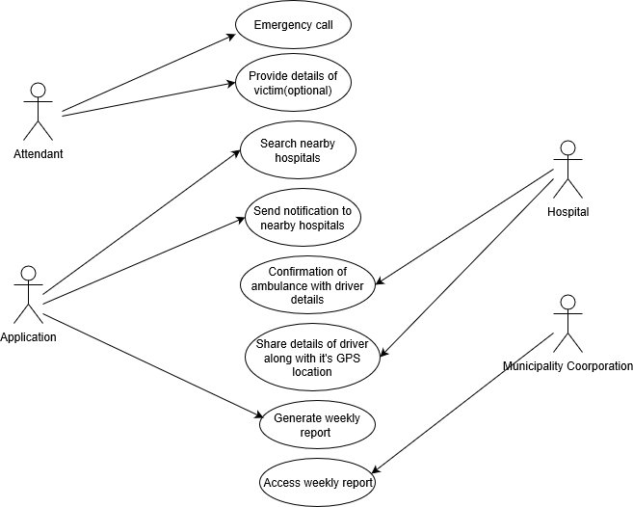

* **Sequence Diagram**

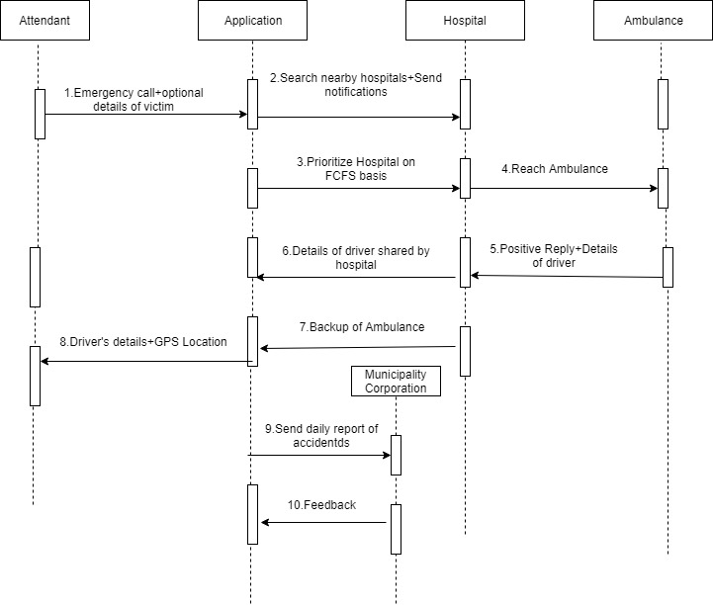

* **Component Diagram**

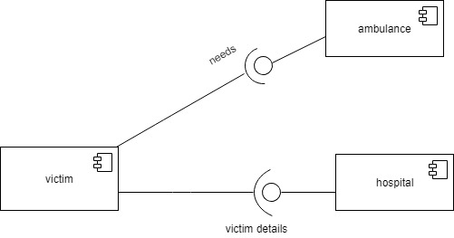

* **ER Diagram**

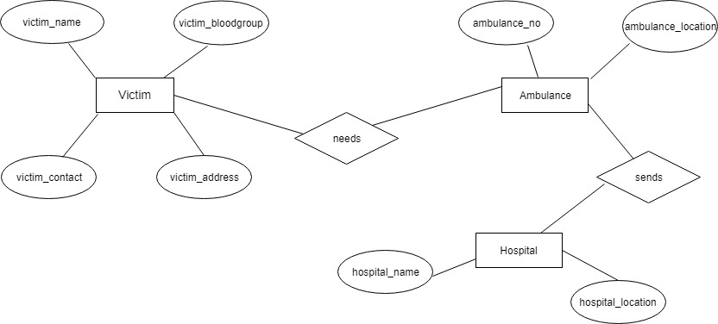

* **Activity Diagram**

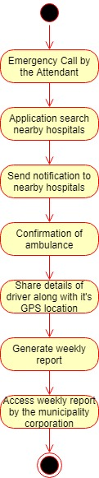

1. **GUI Design**

* **Splash Screen**

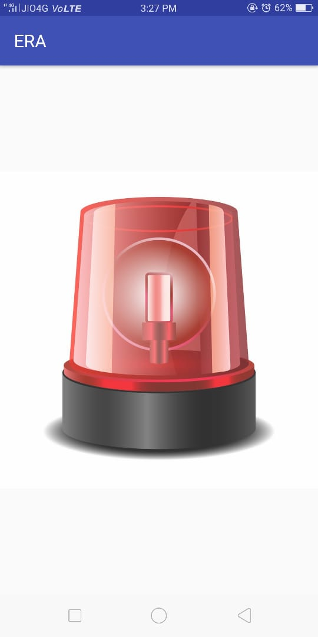

* **Emergency Call**

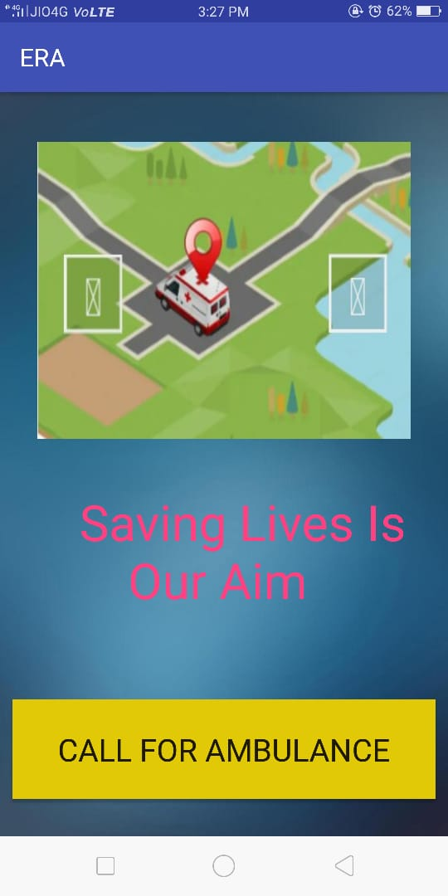

* **Map**

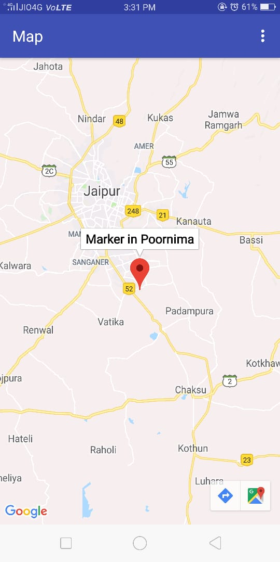

1. **References**

* [**https://bohatala.com/ambulance-management-system/**](https://bohatala.com/ambulance-management-system/)
* [**https://timesofindia.indiatimes.com**](https://timesofindia.indiatimes.com/)
* [**https://irjet.net/archives/V4/i10/IRJET-V4I10148.pdf**](https://irjet.net/archives/V4/i10/IRJET-V4I10148.pdf)
* [**https://www.hindustantimes.com/jaipur/deaths-in-road-accidents-down-in-rajasthan/story-ljaXpRDekyxo885dN1NYpO.html**](https://www.hindustantimes.com/jaipur/deaths-in-road-accidents-down-in-rajasthan/story-ljaXpRDekyxo885dN1NYpO.html)

1. **Guide’s Comments**